Table of Contents
1. Introduction…………………………………………………………………………1
2. Problem Description………………………………………………………………2
3. Project Objectives…………………………………………………………………3
4. SDG Relevance…………………………………………………………………….4
5. Software Development Life Cycle (SDLC)………………………………..5
6. System Requirements……………………………………………………………6
7. System Architecture Design……………………………………………………7
8. System Components and Interactions……………………………………..8
9. UML Use Case Diagram………………………………………………………….9
10. Prototype Development (10 Screens)……………………………………10
11. Git & GitHub Integration………………………………………………………11
12. Project Plan (Gantt Chart)…………………………………………………….12
13. Network Diagram………………………………………………………………...13
14.Software License…………………………………………………………………..14
15. Design Quality (UI/UX)…………………………………………………………15
16.Conclusion…………………………………………………………………………….16
17.References…………………………………………………………………………….17

1. Introduction

Healthcare is one of the most important sectors in society, as it directly affects the well-being and quality of life of individuals. However, many healthcare facilities continue to face challenges such as long waiting times, inefficient patient record management, overcrowded clinics, poor communication between patients and healthcare providers, and limited access to healthcare information. These challenges often result in delays in treatment, reduced patient satisfaction, and increased workload for healthcare staff.
With the rapid advancement of information and communication technology, digital solutions have become essential in improving healthcare service delivery. Modern healthcare systems increasingly rely on digital platforms to streamline operations, enhance communication, and provide convenient access to medical services. Digital healthcare solutions not only improve efficiency but also ensure that healthcare services are more accessible, reliable, and patient-centered.
The Smart Health Access System is a Digital Public Good designed to address these challenges by providing an integrated platform that connects patients, healthcare providers, and administrators. The system enables patients to register online, book appointments, access healthcare information, receive notifications, and communicate with healthcare professionals without the need for unnecessary physical visits. Healthcare providers can efficiently manage appointments, update patient records, and monitor service delivery, while administrators can oversee system operations and generate useful reports.
The implementation of this system is expected to reduce congestion in healthcare facilities, improve patient experience, enhance the management of medical records, and support the digital transformation of healthcare services. By automating key healthcare processes, the system promotes efficiency, transparency, and better healthcare outcomes for both patients and medical practitioners.
Furthermore, the Smart Health Access System contributes to the achievement of Sustainable Development Goal 3 (Good Health and Well-Being) by improving access to healthcare services, reducing waiting times, supporting effective healthcare management, and promoting the use of technology in public health systems. Through this project, healthcare institutions can provide faster, more organized, and more accessible services to the communities they serve.
Overall, the Smart Health Access System represents a modern approach to healthcare management that leverages technology to improve service delivery, enhance communication, and ensure better healthcare accessibility for all users.
This version is suitable for a university project report and should fill about 1–1.5 pages when formatted in Microsoft Word.

3. Project Objectives
The objectives of the Smart Health Access System are:
- Provide online appointment booking.
- Improve patient record management.
- Reduce waiting time.
- Enhance communication between patients and healthcare providers.
- Provide access to healthcare information.
- Support digital healthcare transformation.

4. SDG Relevance
The project supports:
SDG 3 – Good Health and Well-Being
Sustainable Development Goal 3
The system contributes by:
- Improving healthcare accessibility.
- Reducing waiting times.
- Promoting efficient healthcare services.
- Supporting public health management.

5. Software Development Life Cycle (SDLC)
SDLC Model: Waterfall Model
Phase 1: Requirement Analysis
- Identify healthcare challenges.
- Gather user requirements.
- Define system objectives.
Phase 2: System Design
- Design database structure.
- Create system architecture.
- Design UI/UX prototypes.
Phase 3: Development
- Develop frontend interfaces.
- Develop backend functionalities.
- Integrate database.
Phase 4: Testing
- Functional testing.
- User acceptance testing.
- Bug fixing.
Phase 5: Deployment
- Install system on servers.
- Launch system for public use.
Phase 6: Maintenance
- System updates.
- Security improvements.
6. System Requirements
- Functional Requirements
- User Registration
- User Login
- Appointment Booking
- Patient Records Management
- Doctor Management
- Notifications
- Reports Generation
Non-Functional Requirements
- Security
- Reliability
- Scalability
- Usability
- Performance

7. System Architecture Design
Architecture Layers
- Presentation Layer
- Web Application
- Mobile Application

- Application Layer
- Appointment Module
- Patient Module
- Notification Module

- Database Layer
- MySQL Database

ARCHITECTURE DIAGRAM
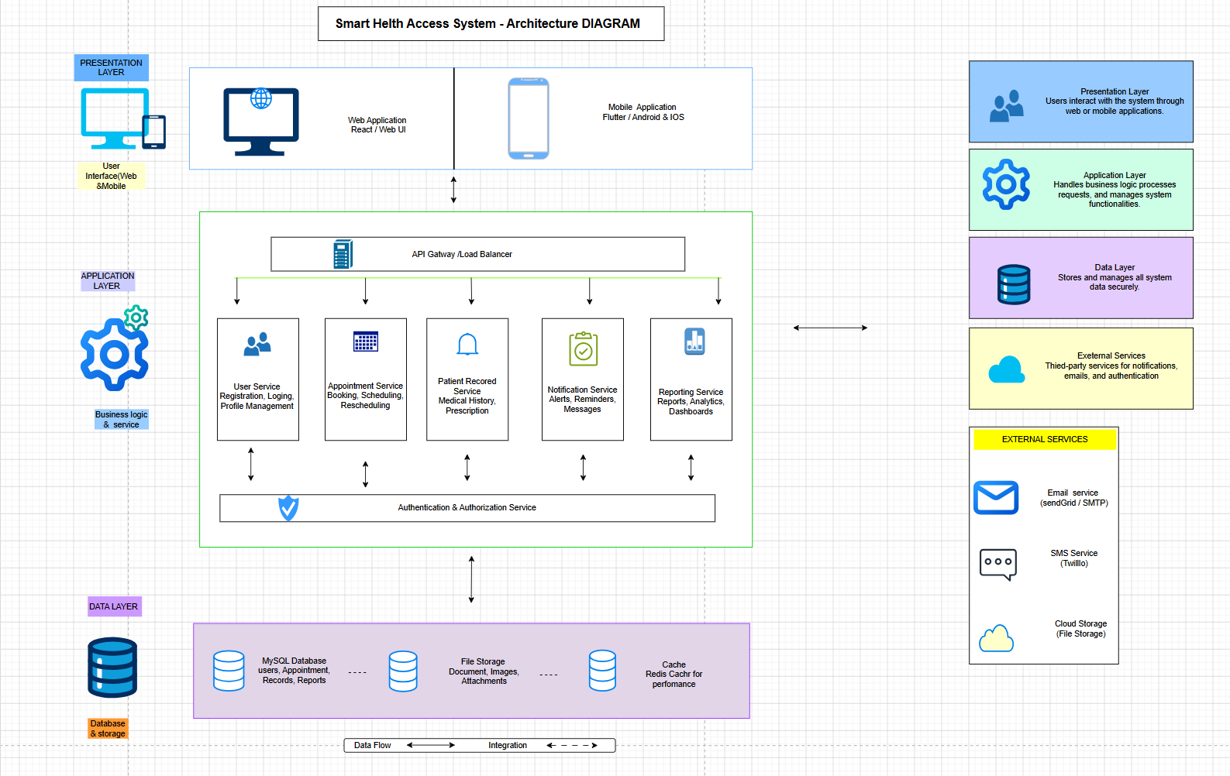

8. System Components and Interactions
Patient
- Registers account.
- Books appointment.
- Views health records.
Doctor
- Reviews appointments.
- Updates medical records.
Administrator
- Manages users.
- Generates reports.
Database
- Stores patient records.
- Stores appointment data.

- UML Use Case Diagram

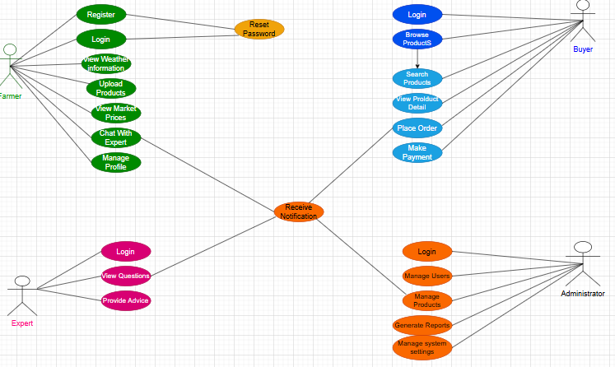

10. Prototype Development

